**Creating A Social Media Ad Campaign In Facebook**

**1.Introduction**

**1.1 Overview**

This project outlines the steps involved in creating a social media ad campaign in Facebook. The goal of the project is to help businesses of all sizes reach their target audience and achieve their marketing goals.

**1.2 Purpose**

Social media advertising is a powerful way to reach potential customers and grow your business. Facebook is one of the largest social media platforms in the world, with over 2.9 billion active users. This makes it a great platform for businesses to reach their target audience.

A social media ad campaign in Facebook can be used to achieve a variety of marketing goals, such as:

* Increasing brand awareness
* Generating leads
* Driving sales
* Promoting a new product or service
* Retargeting website visitors

**2.Problem Definition and Design Thinking**

**2.1 Empathy Map**

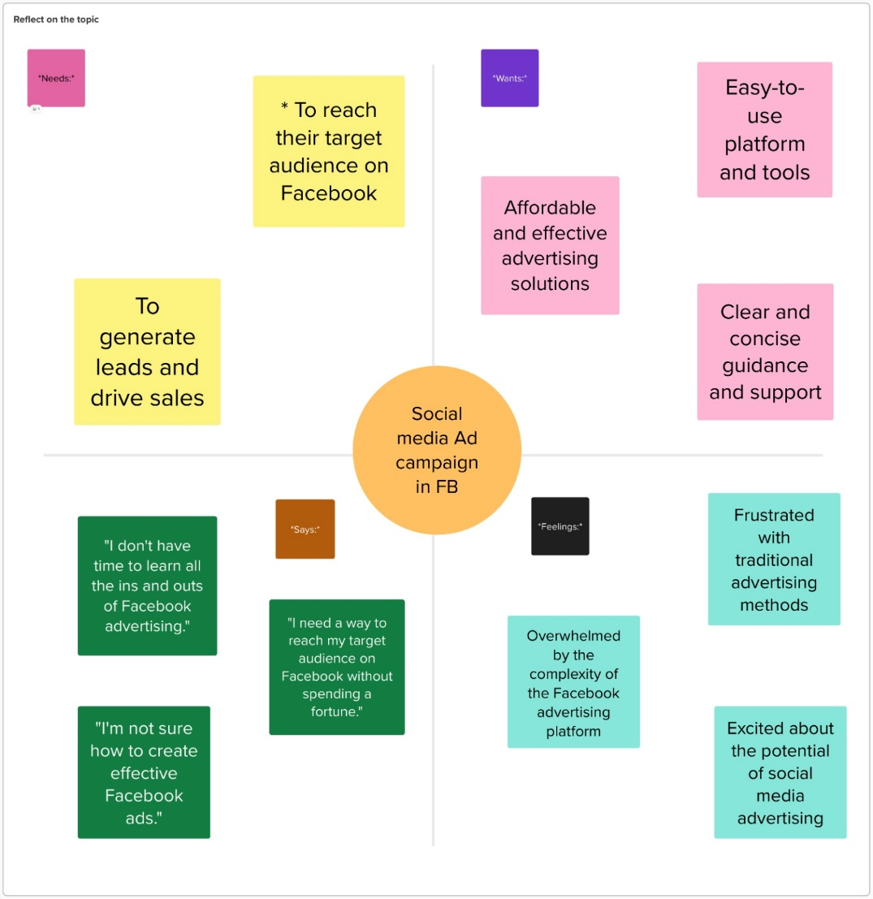

**2.2 Ideation and Brainstorming Map**

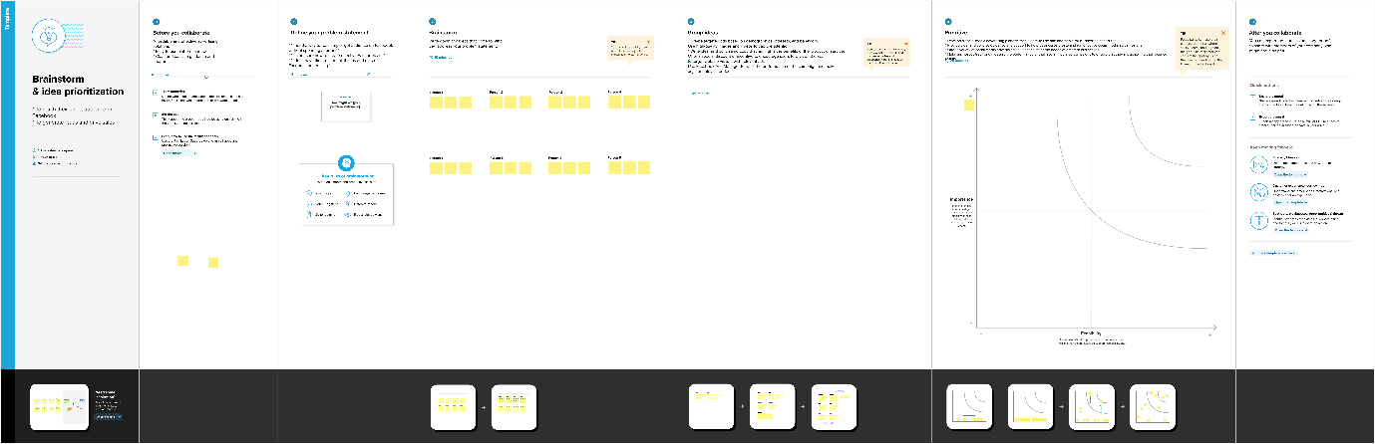

**3.Result**

Final findings (output) of the project

The final output of the project is a social media ad campaign in Facebook. The campaign should be designed to achieve the specific marketing goals of the business.



**BRAND LOGO**

**BRAND NAME : HITOUT SHOES**

**BRAND E-MAIL :** [**hitoutshoes@gmail.in**](mailto:hitoutshoes@gmail.in)

**BRAND FACEBOOK LINK :** [**https://www.facebook.com/hitout11?mibextid=ZbWKwL**](https://www.facebook.com/hitout11?mibextid=ZbWKwL)

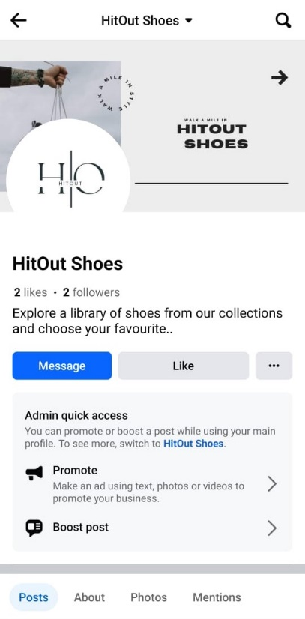

**4.Advantages and Disadvantages**

**Advantages of social media advertising in Facebook:**

* Large audience: Facebook has over 2.9 billion active users.
* Targeted advertising: Facebook allows businesses to target their ads to specific demographics, interests, and behaviors.
* Measurable results: Facebook provides detailed insights into the performance of ad campaigns.
* Cost-effective: Social media advertising is a relatively cost-effective way to reach a large audience.

**Disadvantages of social media advertising in Facebook:**

* Competition: Because Facebook is such a popular advertising platform, there is a lot of competition for ad space.
* Ad fatigue: If users see the same ads too often, they may start to ignore them.
* Negative feedback: Social media users can leave comments and reviews on ads, which can be negative.

**5.Applications**

Social media advertising in Facebook can be used by businesses of all sizes in a variety of industries. Some common applications include:

* E-commerce businesses can use social media advertising to promote their products and drive sales.
* Lead generation businesses can use social media advertising to generate leads from potential customers.
* B2B businesses can use social media advertising to reach decision-makers at other businesses.
* Local businesses can use social media advertising to reach their local community.

**6.Conclusion**

Social media advertising in Facebook is a powerful way to reach potential customers and achieve your marketing goals. By following the steps outlined in this project, you can create a social media ad campaign that is effective and affordable.

**7.Future Scope**

Some enhancements that can be made to social media advertising in Facebook in the future include:

* Better targeting options: Facebook could develop more sophisticated targeting options to help businesses reach their ideal customers.
* More immersive ad formats: Facebook could develop new ad formats that are more immersive and engaging for users.
* More advanced analytics: Facebook could provide more advanced analytics to help businesses measure the performance of their ad campaigns and optimize them for better results.